(a) To make sure that you have done this correctly, **report the dimensions of the**

**new data frame.**

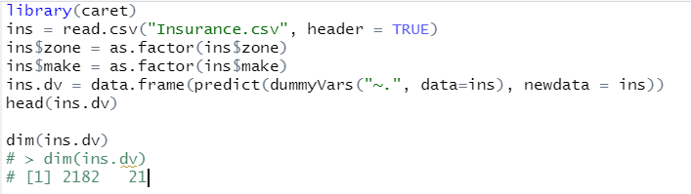

2. Run a principal components analysis on these data, excluding the response variable

per, using scale.=TRUE to standardize the data.

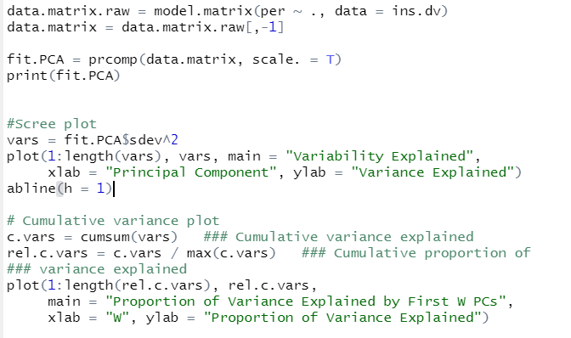

(a) **How many PC’s get chosen** if you use the guideline of choosing all PC’s with

higher than average contributions to the explained variance?

* I might choose 15 variables

(b) Make a scree plot and a cumulative variance plot. **Show these plots.**

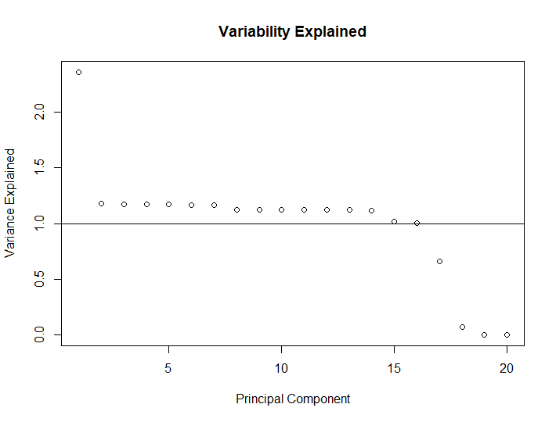

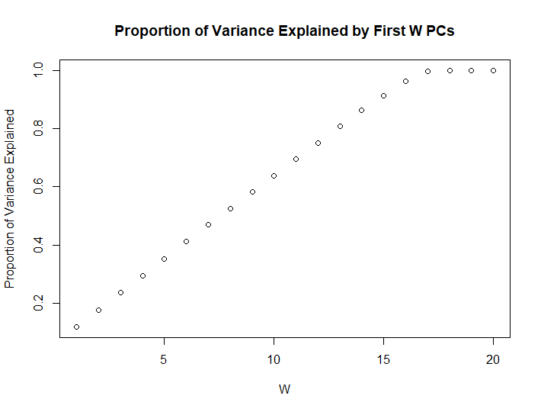

(c) Based on these plots, **indicate how many PC’s** you think explain “enough”

variability while achieving dimension reduction? **Explain very briefly why**

**you chose that number.**

* 16 PC’s might be enough because until the 17th PC, the proportion of variance explained get bigger linearly.